**ASSINGMENT**

|  |  |
| --- | --- |
| Assignment Date | 19 September 2022 |
| Student Name | PRIYA G |
| Student Roll Number | 715319106011 |
| Maximum Marks | 2 Marks |

**I INTRODUCTION**

The digital transformations in various industries have mainly been driven by the development of artificial intelligence (AI) [1]. Over the past four years, there has been a tremendous growth in AI investments worldwide. The 2016 report by Gartner revealed that the actual deployment of AI technology had been undertaken by a mere 9% of organizations, but the number increased to 25% three years later in 2019 with the Enterprise Digital Research projecting the growth rate to double in the subsequent five years. Also, it is now the number one strategic technology for organizations. Digital transformations now rely on AI riding on the developments in networking and greater data processing.

AI is considered as a crucial business solution and basis for capabilities in all types of organizations [3]. The economic growth of various nations is also driven by AI as it provides ample business opportunities. AI applications can improve organizational performance and create competitive advantage [4]. Banks that have adopted AI technology have demonstrated a boost in interest incomes, lower costs and enhanced customer satisfaction.

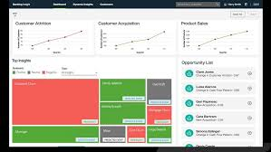

**II ARTIFICIAL INTELLIGENCE IN BANKING SERVICE SECTOR**

Constant improvements on customer service and the use of advanced technologies can redefine the processes of banking services as proven by Google and Face book. Yet, many conventional banking services providers fail to provide the needed flexibility and innovative capabilities. Hence, Fin Techs are deemed as the more viable break through to conventional banking service sectors. Fin Techs skip on legacy architectures and instead use advanced technologies along with lean and agile procedures to produce improved customer positioning, reduced costs and accelerated innovations speeds. They have catalyzed major innovations in diverse areas including wealth management, payment, lending and crowd funding

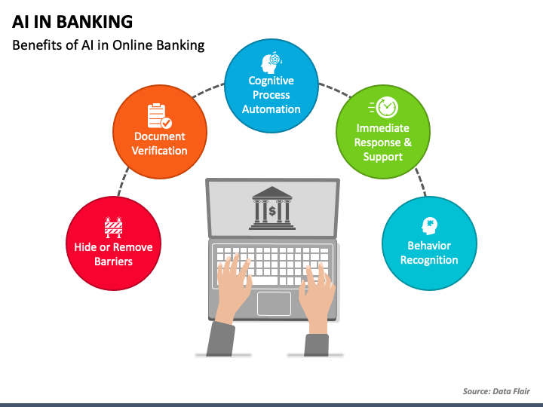

* A beautifully designed graphic depicts the benefits of AI in online banking.
* An impressive pentagon-shaped pattern with eye-catching vectors showcases the AI in banking use cases.
* An innovative info graphic with appealing icons presents the top reasons banks use artificial intelligence.
* The uses of AI in banking have been illustrated in a comprehensible manner.
* A comprehensively designed info graphic with eye-pleasing icons depicts how banks extend the use of artificial intelligence technologies to improve back-office processes and customer experience.
* A chart illustrates the banking applications of machine learning and natural language clearly and concisely.

Write a program which will find all such numbers which are divisible by 7 but are not a multiple of 5, between 2000 and 3200 (both included). The numbers obtained should be printed in a comma-separated sequence on a single line.

|  |
| --- |
| **Solution:** |
|  | l=[] |
|  | for i in range(2000, 3201): |
|  | if (i%7==0) and (i%5!=0): |
|  | l.append(str(i)) |
|  |  |
|  | print (','.join(l)) |
|  | #----------------------------------------# |
|  | #----------------------------------------# |
|  |  |

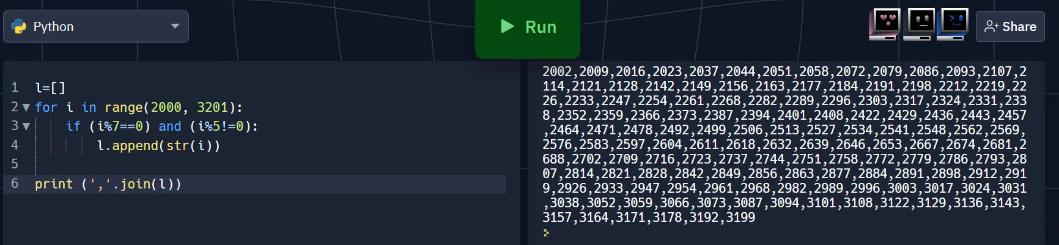

With a given integral number n, write a program to generate a dictionary that contains (i, i*i) such that is an integral number between 1 and n (both included). and then the program should print the dictionary.

Suppose the following input is supplied to the program:8

Then, the output should be:

{1: 1, 2: 4, 3: 9, 4: 16, 5: 25, 6: 36, 7: 49, 8: 64}

|  |
| --- |
| **Solution:** |
|  | n=int(input()) |
|  | d=dict() |
|  | for i in range(1,n+1): |
|  | d[i]=i*i |
|  |  |
|  | print d |
|  | #----------------------------------------# |
|  | #----------------------------------------# |

